Multi Floors Parking System (Python)

Description
This is a console-based parking management system written in Python.
It allows users to manage parking slots by defining the number of floors, rows, and columns.
The system represents a real-world multi-floor parking area, operated from the parking gate.

Purpose of the System
This program is designed to help a parking attendant working near the parking gate to manage vehicle parking easily.
The attendant can park vehicles, remove them when they exit, and view the current parking status using simple commands.
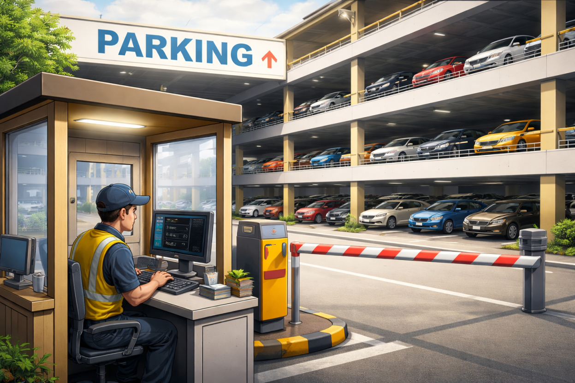

Image Representation
The project image represents:
- A multi-floor parking system
- Clearly defined parking slots
- A bar gate at the entrance
- A parking attendant near the gate operating the system

Features
- Dynamic creation of parking slots
- Park a vehicle (in)
- Remove a vehicle (out)
- Display parking slots (display)
- Exit the system (exit)
- Prevents duplicate vehicle numbers
- Checks if parking is full

How It Works
- The parking area is stored as a 3D list:
parking[floor][row][column]
- Each slot initially contains "Empty"
- Vehicles are parked in the first available empty slot
- Vehicle numbers must be natural numbers
- The parking attendant operates the system from the parking gate:
  - Uses in when a vehicle enters
  - Uses out when a vehicle exits
  - Uses display to check available and occupied slots

How to Run
python parking_system.py

Commands
- in → Park a vehicle
- out → Remove a vehicle
- display → Show parking status
- exit → Exit the program

Technologies Used
- Python
- Lists (3D list)
- Loops and conditional statements

